Write in complete thoughts or sentences.
1. Recall the “Drive a Nail” Activity. What important relationships did you learn?

2. State the “Law of Conservation of Energy.”

3. Give an example that expresses all facets of this law.

4. What is efficiency?

5. How does one calculate efficiency?

6. What is usually the cause of a device not being efficient and what type of energy loss results?

7. Give an example of each type of energy transformation. The first one is done for you.
a. Light(solar) motion ______solar-powered car_______
b. Motion Elastic ________________________________
c. Electrical Sound _______________________________
d. Chemical Motion ______________________________
e. Nuclear Light _________________________________
8. Describe the energy transformation for each transformation. The first one is done for you.
a. My car moves fast. ______chemical _--> motion__________
b. The rotating fan really moves air. __________________________________
c. The plant grows well in the window. ________________________________
d. Memory Foam pillows are nice. ____________________________________
e. The roller coaster is ready to go fast! _________________________________
9. Which way does energy flow?

10. Why is this direction of flow the case? (referring to question 9)

11. List all the units used to measure energy that we have discussed so far: (we actually described 4)

12. List all the renewable energy sources.

13. Why are these considered renewable?

14. List all the non-renewable energy sources we have studied.

15. Why are these considered non-renewable?

16. What are good ways to keep something cold? List as many ways as possible?

17. What are good ways to melt all snow?

18. Define insulator.

19. Define conductor.

20. If something is a good conductor of thermal energy, what other energy is it usually good at conducting?

21. What did you learn about mixing different amounts of hot water and cold water in relation to the final temperature of the mixture?

22. What color of roof is good to have during the summer? Why?

23a. Referring back to Activity 53, what were all that ways to keep thermal energy from seeping into the home?

23b. What items lost "less" thermal energy? Look back at the table.

24a. In thinking about all the types of energy, what could be considered the ultimate source of all the energy types? Why?

24b. How efficient is this energy source compared to other types? Is it renewable? (2 questions to answers!)

25. Look at the rollercoaster drawing. Explain what is status of the Kinetic (motion/mechanical) energy and the Gravitational Potential energy.
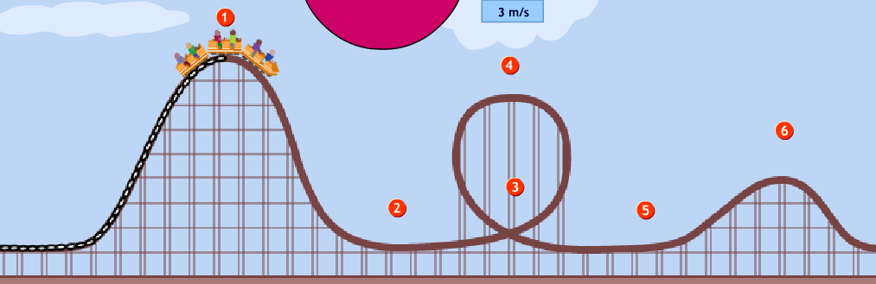
At point 1:
At point 2:
At point 3:
At point 4:
At point 5:
At point 6:

26a. What equation did you use to calculate the calories released from the corn curl?

26b. What mass did you use: the mass of the corn curl or the mass of the water? Why did this work?

27. How efficient was our calorimeter? How did you know?

28. Pick one energy source form Activity 64 and discuss the strengths as well as the trade-offs.

