**Title** Pre/Post test

**Project title** If You Build It, Will It Fly??????

**Grade Band Team:** Grades 6-8 ,Team C

**Team members** Shanon Rodenberg, Bruce Brewer, Jean Polk, Steve Schauf,

Roxanne Kravik, Brenda Freit

**Date** July 26, 2011

1. What is a force?
2. A power used by Yoda
3. A push, pull or lift
4. A type of energy

D. A law of motion

1. Which of these uses the force of gravity to make it move?
2. A sailboat moving across a lake
3. A car making a right turn
4. A snow sled going downhill
5. A bicycle rolling to a stop
6. If these four identical balls are dropped at the same time and from the same height, which ball will land **first**?

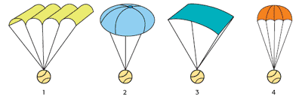

1. Ball 1
2. Ball 2
3. Ball 3
4. Ball 4
5. Circle all of the following forces are involved in flight?

Thrust Drag Lift Gravity

1. Kelly slides a flat rock across the smooth ice of a frozen pond. The rock slows down after several seconds. What causes the rock to slow down?
2. The thickness of the ice
3. The temperature of the air above the ice
4. The force of friction between the ice and the rock
5. The gravitational force between the ice and the rock

*For questions 6 & 7,* refer to the following information.

Meg designs an experiment to see which of three types of sneakers provides the most friction.

She uses the following equipment: 1) Sneaker 1, 2) Sneaker 2, 3) Sneaker 3, and 4) Spring scale. She uses the setup illustrated below and pulls the spring scale to the left.

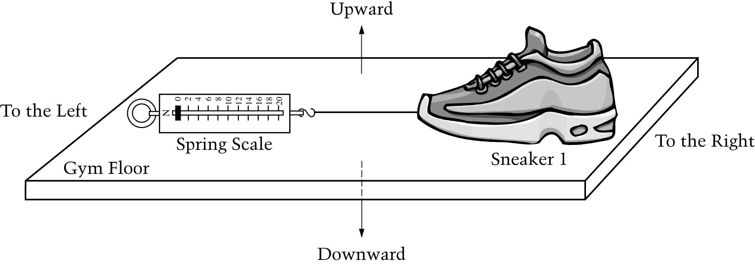

1. In what direction does the force of friction act?
2. To the left
3. To the right
4. Upward
5. Downward
6. Meg tests one type of sneaker on a gym floor, a second type of sneaker on a grass field, and a third type of sneaker on a cement sidewalk. Her teacher is not satisfied with the way Meg designed her experiment. Describe one error in Meg's experiment.
7. In the drawing below, the arrows labeled Force 1 and Force 2 represent two forces acting on an object. The directions of the arrows show the directions of the forces, and the lengths of the arrows represent the strengths of the forces. Which answer choice shows an object being acted upon by forces that do **not** add up to zero?
8. 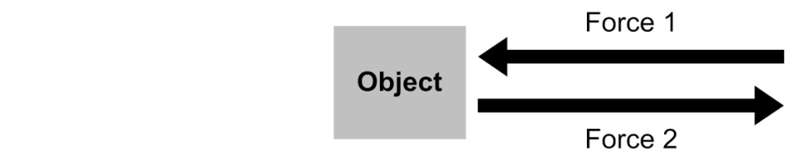
9. 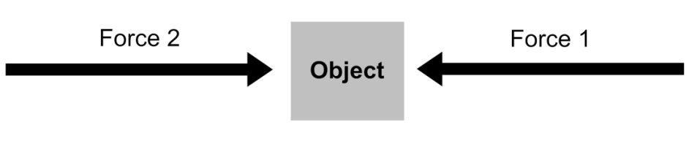
10. 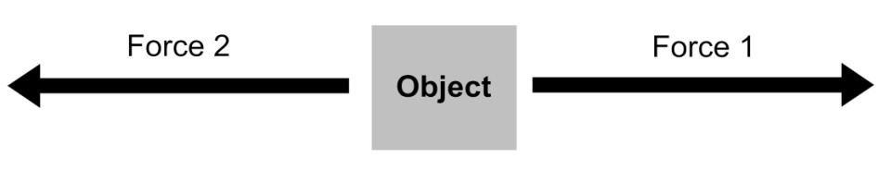
11. 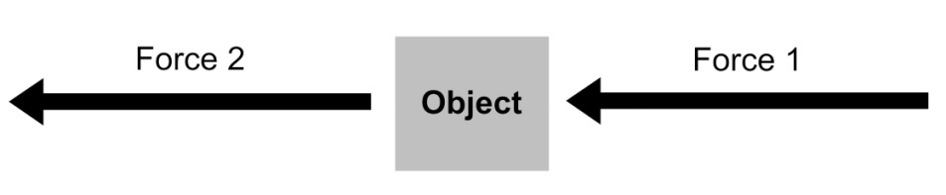

*For questions 9-10,* refer to the following information.

The figure below shows a 2-kilogram (kg) object. A 10-newton (N) force pushes the object horizontally across a level flat surface. The frictional force that results from contact with the surface produces a 2-N force that opposes the direction of the object's movement.

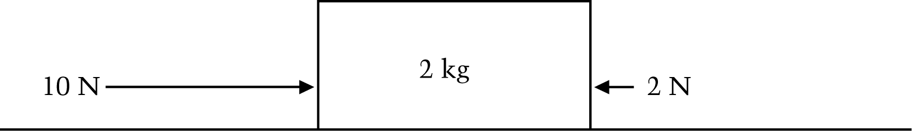

1. Calculate the net force on the object in newtons (N). Show your calculations.
2. Calculate the acceleration of the object in meters per second squared (m/s2). Show your calculations.

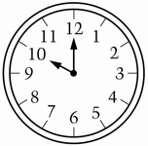

1. How many degrees are in the **acute** **angle** formed   
   by the hands of the clock in the figure to the right?
   1. 10°
   2. 30°
   3. 60°
   4. 120°

4

3

1

2

1. Which of the following lists the angles shown above in order of measure **from smallest to largest**?
   1. 1, 2, 3, 4
   2. 2, 3, 4, 1
   3. 3, 2, 1, 4
   4. 3, 1, 4, 2

13. How many of the angles in this triangle appear to be smaller than a right angle?

A. None

B. One

C. Two

D. Three

C:\Users\Shanon\AppData\Local\Microsoft\Windows\Temporary Internet Files\Low\Content.IE5\MDSG171T\MC900048326[1].WMF14. Measure the angle of the airplane wing to the fuselage.

This angle

What would be the measure of the

supplementary angle ? ____________

1. What largest number of right angles a triangle can have. ____________

Justify your answer with examples.