**Catapults: Launching into Physics**

**Pre and Post Assessment**

**Stem Grant Grade Band Team: 6-8A**

**July 25, 2011** Jo Brinks

Sarah Dahlen

Deb Ferries

Amy Langner

Brian McGuire

Kristin Nelson

1. Figure B is a _____________ of figure A.

A

B

* 1. Dilation
  2. Reflection
  3. Rotation
  4. **Translation**

A

B

2. Figure B is a __________ of figure A.

1. Dilation
2. **Reflection**
3. Rotation
4. Translation

3. What makes two shapes congruent?

1. Same shape, different size
2. Different shape, different size
3. **Same shape, same size**
4. Different shape, same size

4. What makes two shapes similar?

1. **Same shape, different size**
2. Different shape, different size
3. Same shape, same size
4. Different shape, same size

5. Calculate the **area** of a **circle** with a *12 inch* **diameter**. (show work)

113.04 = 62(π), 36(3.14)

6. What unit of measure would you use to measure the length of a pencil?

* 1. Meter
  2. Millimeter
  3. Kilometer
  4. **Centimeter**

7. What is the name of the following shape?

1. Square
2. Rectangle
3. Cube
4. **Rectangular prism**

8. Two main outside **forces** acting on most anything on earth are

1. friction and mass.
2. **friction and gravity.**
3. gravity and inertia.
4. gravity and mass.

9. An example of a **balanced** **force** is

1. a car sliding on ice.
2. **a tug-of-war game in which no one wins.**
3. a car hitting a telephone pole.
4. a roller coaster going down the first drop.

10. An example of an **unbalanced** **force** (net force) is

1. a car parked in the garage.
2. a tug-of-war game in which no one wins.
3. a bridge.
4. **a roller coaster going down the first hill.**

11. In physical science, a **push** or **pull** is called a(n)________.

1. gravity
2. **force**
3. universal law
4. inertia

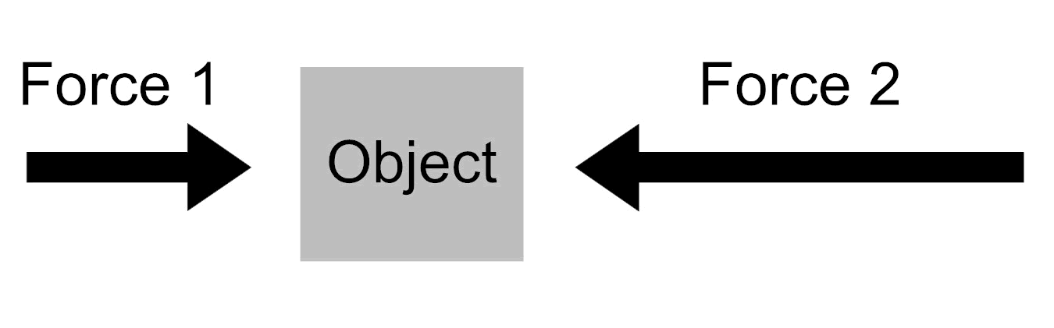In the drawing below, the arrows labeled Force 1 and Force 2 represent two forces acting on an object. The directions of the arrows show the directions of the forces, and the lengths of the arrows represent the strengths of the forces.

12 Newtons

20 Newtons

12. Which total force (net force) is equal to the two forces acting on the object?

1. **8 Newtons**
2. 22 Newtons
3. 32 Newtons
4. 240 Newtons

Description: C:\Program Files (x86)\Microsoft Office\MEDIA\CAGCAT10\j0278882.wmf 13. Which vector diagram accurately shows forces acting on the car **as** it is being lifted?

a. b.

F*applied*

F*g*

F*f*

F*applied*

F*applied*

F*g*

F*f*

F*applied*

F*applied*

F*g*

F*f*

F*applied*

F*applied*

F*g*

F*f*

F*applied*

c. d.

14. Which graph below shows an object moving at a constant speed?

A. B. C. D.

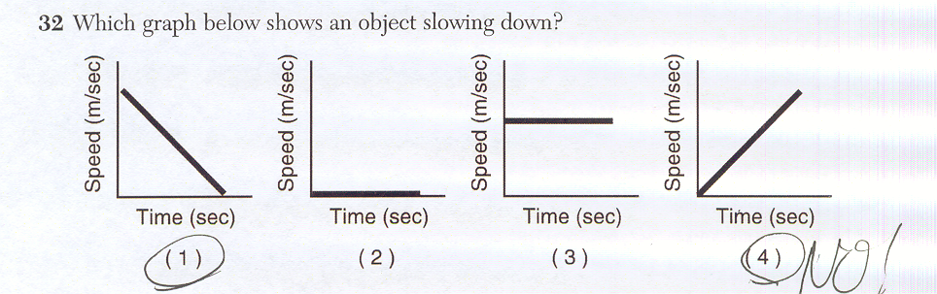

15. Rafael and Sammy were playing with soccer balls on a flat tile floor. Each boy rolled a soccer ball at the same time, and the balls hit, as shown below.

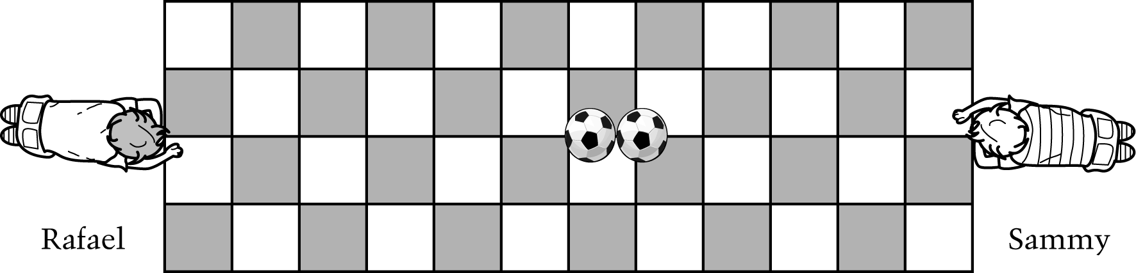

Which boy rolled his ball faster? How do you know? Draw two vector diagrams indicating the forces exerted on each ball just before Rafael and Sammy release their ball.

|  |
| --- |
| **Complete** Student response indicates Rafael and compares the number of rows of tiles over which each boy's ball rolled. Student response may or may not include quantitative information in the comparison. |
| **Partial** Student response indicates Rafael and indicates that Rafael's ball traveled farther, but does not compare the number of rows of tiles over which each boy's ball rolled. |
| **Unsatisfactory/Incorrect** Student response is inadequate or incorrect.  Fg  Fg |

Fa

Ff

Ff

Fa

FN

FN

Sammy

Rafael