Challenge/The Question:

Hypothesis:

Vocabulary:
chemical properties

miscible, miscibility

physical properties

toxic

Thinking Space:

Appearance:

Miscible in water and ethanol:

Contains water:

Corrosive

pH Scale

Back Ground Notes

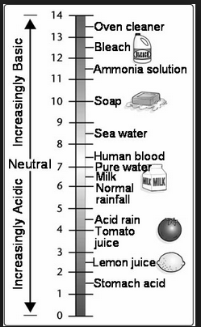
Which of the liquids do you think will be flammable? What makes you think this?

