Activity 57 Graded Analysis:

3. (UC ASSESSMENT) Your friend says that when he measured how much electricity was provided by a battery, it was less than the potential energy in the battery. He concluded that the transformation violated the Law of Conservation of Energy. Do you agree? Explain, using the ideas of the Conservation of Energy.

Notes:
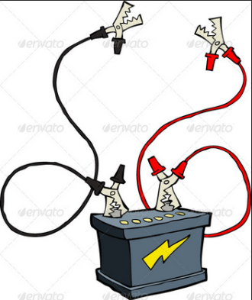
In general the scenario is that the battery, which starts out at 100%, transfers its energy to the meter but only registers some value less than 100%, let’s say 95%. Now the friend argues that by this demonstration he has shown that 5% of the energy was lost and thus the Law of Conservation of Energy was violated.
Now you, the wiser one, disagrees (state this in your answer) and proceeds to tell him why and with supportive evidence. You do this in three parts:
1. You discuss what it means when a scientific law is claimed. (see notes in your binder or online if you missed them…you may even have a copy of the power point.)
2. You explain what the Law of Conservation of Energy states.
3. Then explain the transformation as your friend has seen and how it really is.

