If the copper metal that started out in the paper is not in the smoke, what do you think happened to it?
Challenge:

Hypothesis:

Vocabulary:
Incineration:

Combustion:

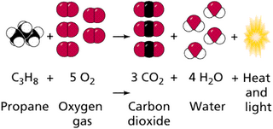

Thinking Space:
What are ways to deal with the waste created in computer manufacturing?

What do you know about combustion?

What are the two main products of the incineration of the metal paper?

How did incineration change the paper?

Based on what you observed, how might incineration be helpful in waste disposal?

What do you predict is in the smoke?

Do you think the copper from the metal paper is now present in the smoke or in the ash?

If the copper metal that started out in the paper is not in the smoke, what do you think happened to it?

