1. Which of the three items in your table, “Testing for Copper,” —paper, smoke, or ash— are products of incineration?

2. Which of the products of incineration contained copper? Explain your evidence.

3. How did incineration change the metal paper?

4. What are the advantages and disadvantages of using incineration to dispose of heavy metals wastes?

5 . Look at the information provided on Transparency 26.1, “Municipal Waste Disposal in the U.S. and Japan,” and Transparency 26.2, “Relative Landmasses of the U.S. and Japan.” Based on what you know about incineration and the information shown, why do you think these two countries handle waste disposal differently?

Transparency 26.1
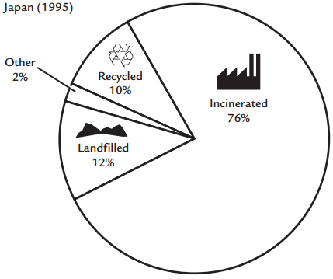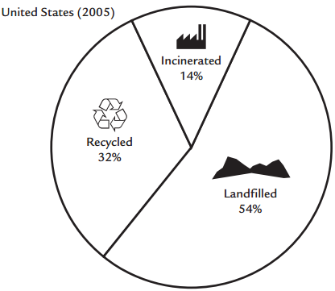
Transparency 26.2
