1. (Collecting #1) Look at the diagram of a roller
coaster below.
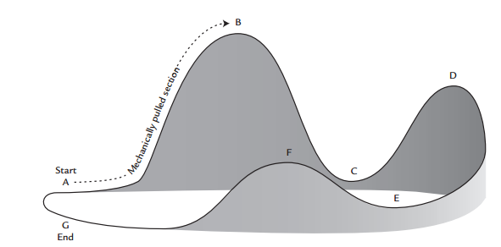
At which point does a train on this
roller coaster:
- have the most gravitational potential energy? Explain your choice.

- have the most kinetic energy? Explain your choice.

c. have both kinetic and gravitational potential energy? Explain your choice.

2. Kinetic energy is related to the speed of an object. In which place, Point E or Point F, is the train moving faster? Explain in terms of kinetic energy.

3. As the train travels on the track, the energy of the train changes back and forth from gravitational potential to kinetic. What other energy transformations occur as the train travels the track? Explain.

4. Why can’t a roller coaster go up a hill that is higher than the hill it just came down?

