1. What are good safety rules to always follow in a chemistry lab?
2. List hazards with their meaning and precautions.
3. What is the density of water?
4. If something is more dense than water, would it sink or float in water?
5. If two liquids are not miscible, what does that mean?
6. If liquid A has a density of 0.5g/ml
& Liquid B has a density of 0.95g/ml
& Liquid C has a density of 9.5 g/ml
& Liquid D is water
Considering that none of these are miscible, were in a jar together that had been shaken, what order would the liquids layer? Use the diagram to aid you.
7. What are the signs that a chemical reaction has occurred?

8. How would you separate fine sand from water?

9. How would you separate salt from water?

10. How would you separate 1,000,000 iron beads from 1,000,000 copper beads of the same diameter?

11. Know how to read a graduated cylinder, a ruler, and a triple beam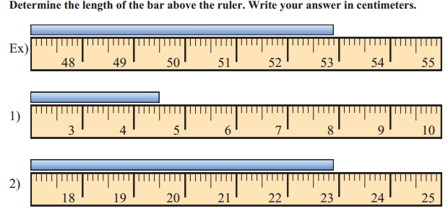 balance.

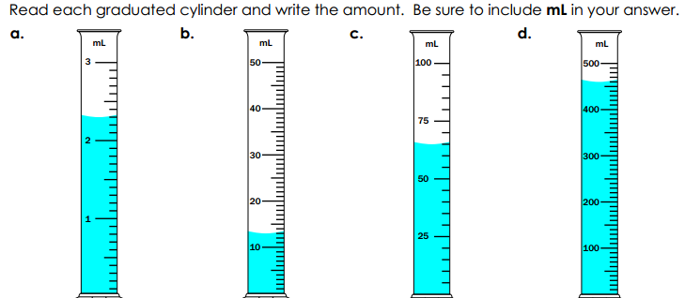
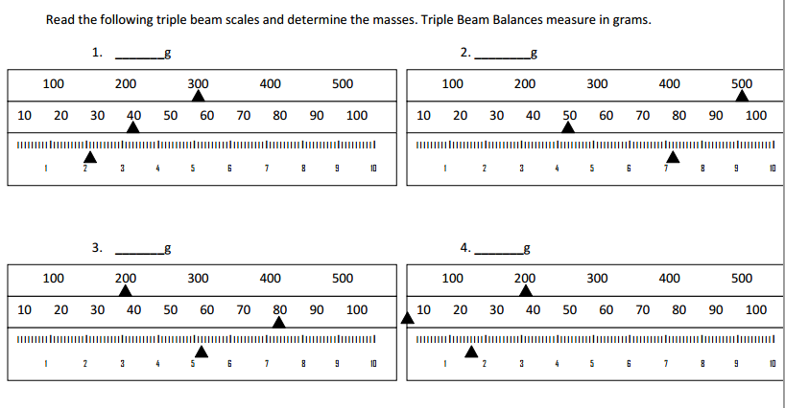
12. Know how to calculate volume of a geometric shape such as a cube or a cylinder. First what is the formula for the volume of a rectangular prism? Then what is the formula for the volume of a cylinder? Now find the volume of these objects:
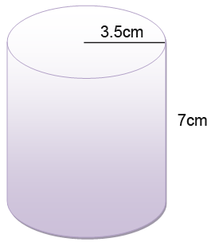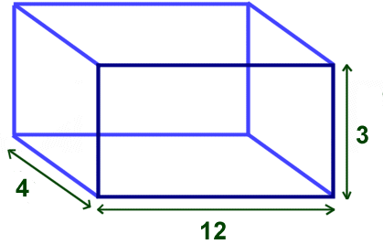
13. Know how to calculate density. What is the formula for calculating density? Now use it to determine which sample is more dense.
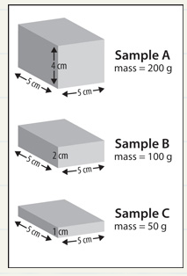
14. Explain what steps a hazmat scientist would take when approaching a barrel of a mixture of an unidentified substance.

Directions: The MSDS sheet for a common laboratory chemical appears on the last pages. Answer the following questions on this paper (complete sentences are not needed).
1. What is the name of the chemical?

2. Can you find a chemical formula for this chemical? What is it?

3. Is this chemical flammable?
- If involved in a fire, what type of extinguisher should be used?
-Should any other special procedures be used in fighting fires?
-Are there any unusual fire or explosion dangers?

4. What dangers does this chemical pose to your health?

5. What should you do if you are exposed to this chemical?

6. Are there any conditions under which this chemical may react dangerously?

7. What should you wear when working with this chemical? Is other protective equipment needed?

8. What other kinds of important general information is given on an MSDS sheet (no need to list specific info for your chemical)

