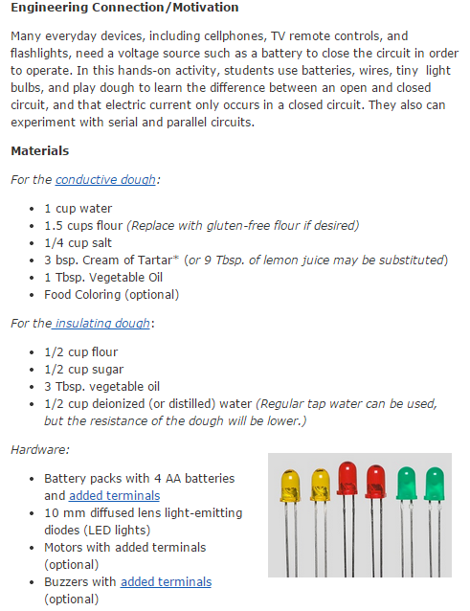
Link for conductive dough: http://courseweb.stthomas.edu/apthomas/SquishyCircuits/conductiveDough.htm
Link for isolative dough:
http://courseweb.stthomas.edu/apthomas/SquishyCircuits/insulatingDough.htm
Adding Terminals link:
http://courseweb.stthomas.edu/apthomas/SquishyCircuits/leads.htm
Link to purchase kits: http://squishycircuitsstore.com/kits.html
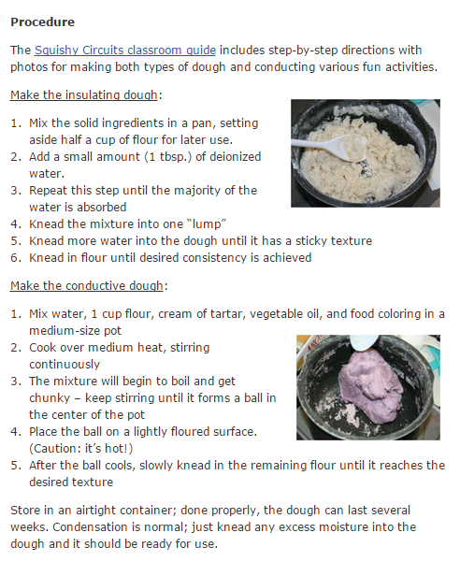
Link for Squishy Circuit Classroom guidelines: http://courseweb.stthomas.edu/apthomas/SquishyCircuits/PDFs/Squishy%20Circuits%20Classroom%20Guide.pdf
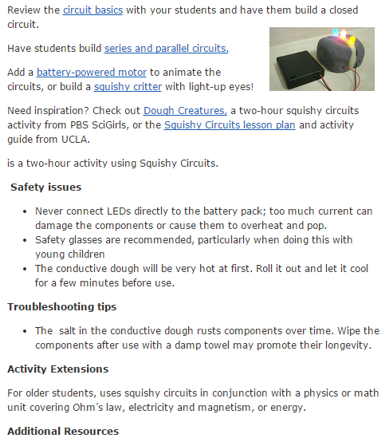
Links for those mentioned in the lesson plan are below:
Link for Circuit Basics:
http://courseweb.stthomas.edu/apthomas/SquishyCircuits/PDFs/Circuit%20Basics.pdf
Link for series & parallel circuits:
http://courseweb.stthomas.edu/apthomas/SquishyCircuits/PDFs/Circuits.pdf
Link for motor circuit:
http://courseweb.stthomas.edu/apthomas/SquishyCircuits/PDFs/Motor%20Circuit.pdf
Link for squishy critter:
http://courseweb.stthomas.edu/apthomas/SquishyCircuits/PDFs/Squishy%20Animal.pdf
Link for Dough Creatures:
http://www-tc.pbs.org/teachers/includes/content/scigirls/activities/tech/doughcreatures.pdf
Link for squishy circuit lesson plans:
http://beam.ucla.edu/sites/default/files/docs/Squishy_Circuits.pdf

