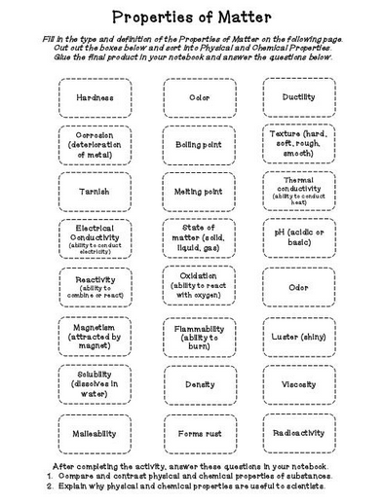

*Sort the following into two categories: Physical Properties and Chemical Properties.*