Problem: State the Question

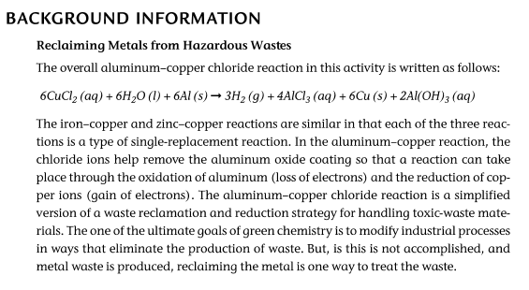
Hypothesis: (Make an educated guess based on your background information. Do this step before conducting the lab.)

Procedure:

Data: Title: ________________
CUP

1

2

3

4

From Step 9 Title: _______________________________________
Cup | Metal | Observations | Results of ammonia test
1
2
3
4

Analysis: Described what happened based on your observations. State the obvious from your data tables. (Hint: we discussed these in class, so use your notes.)
What are your initial observations?

What did the metals do?

What type of reactions did you experience? And how do

