Frog Dissection: External Anatomy
External Anatomy: What does...
Dorsal mean?

Ventral mean?

Anterior mean?

Posterior mean?

Head mean?

Torso mean?

1. Observe the dorsal and ventral sides of the frog.
Dorsal side color ___________ Ventral side color ____________
2. Examine the hind legs.
How many toes are present on each foot? ________
Are the toes webbed? ______
3. Examine the forelegs.
How many toes are present? _________Are the toes webbed? _______
4. What does amphibian mean? ___________________________ Why is it named that? ____________________________________________________________________________________________________________________________________________________
5. Name 2 ways forelimbs are different than hind limbs.

6. How does the tympanic membrane work?

7. Is the frog's skin scaley or slimey? ____________

Anatomy of the Frog's Mouth
1. Locate the tongue. Does it attach to the front or the back of the mouth? __________ Draw a sketch of the tongue, paying attention to its shape.
Tongue Sketch:

2. The frog’s tongue is anchored in the very front – opposite to the orientation and anchoring of humans. Why do you think this is so?

3. In the center of the mouth, toward the back is a single round opening. This is the ____________________. This tube leads to the stomach.
4. Close to the angles of the jaw are two openings, one on each side. These are the _____________________ tubes. They are used to equalize pressure in the inner ear while the frog is swimming.
5. To what structure does the Eustachian tube attach? _____________________
6. Just behind the tongue, and before you reach the esophagus is a slit like opening. This slit is the _______________, and it is the opening to the lungs. The frog breathes and vocalizes with this structure.
7. The frog has two sets of teeth. The _______________ teeth are found on the roof of the mouth. The __________________teeth are found around the edge of the mouth. Both are used for holding prey, frogs swallow their meals whole and do NOT chew. Run you finger over both sets of teeth and note the differences between them.
8. Label each of the structures underlined above. 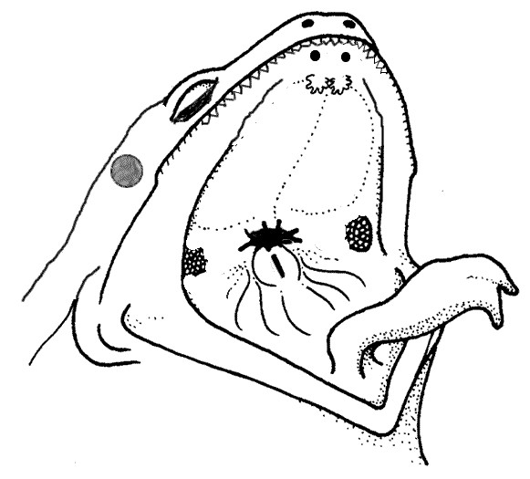
Draw any additional sketches here.
9. Complete the table.
Structure | Function | Location
Vomerine Teeth
Eustachian Tubes
Tympanic Membrane
Esophagus
Glottis
Tongue

Internal Frog
Fat Bodies --Spaghetti shaped structures that have a bright orange or yellow color, if you have a particularly fat frog, these fat bodies may need to be removed to see the other structures. Usually they are located just on the inside of the abdominal wall. Peritoneum A spider web like membrane that covers many of the organs, you may have to carefully pick it off to get a clear view.
Liver--The largest structure of the the body cavity. This brown colored organ is composed of three parts, or lobes. The right lobe, the left anterior lobe, and the left posterior lobe. The liver is not primarily an organ of digestion, it does secrete a digestive juice called bile. Bile is needed for the proper digestion of fats.
Heart - at the top of the liver, the heart is a triangular structure. The left and right atrium can be found at the top of the heart. A single ventricle located at the bottom of the heart. The large vessel extending out from the heart is the conus arteriosis.
Lungs - Locate the lungs by looking underneath and behind the heart and liver. They are two spongy organs.
Gall bladder--Lift the lobes of the liver, there will be a small green sac under the liver. This is the gall bladder, which stores bile. (hint: it kind of looks like a booger)
Stomach--Curving from underneath the liver is the stomach. The stomach is the first major site of chemical digestion. Frogs swallow their meals whole. Follow the stomach to where it turns into the small intestine. The pyloric sphincter valve regulates the exit of digested food from the stomach to the small intestine.
Small Intestine--Leading from the stomach. The first straight portion of the small intestine is called the duodenum, the curled portion is the ileum. The ileum is held together by a membrane called the mesentery. Note the blood vessels running through the mesentery, they will carry absorbed nutrients away from the intestine. Absorption of digested nutrients occurs in the small intestine.
Large Intestine--As you follow the small intestine down, it will widen into the large intestine. The large intestine is also known as the cloaca in the frog. The cloaca is the last stop before wastes, sperm, or urine exit the frog's body. (The word "cloaca" means sewer)
Spleen--Return to the folds of the mesentery, this dark red spherical object serves as a holding area for blood.
Esophagus--Return to the stomach and follow it upward, where it gets smaller is the beginning of the esophagus. The esophagus is the tube that leads from the frogs mouth to the stomach. Open the frogs mouth and find the esophagus, poke your probe into it and see where it leads.

Urogenital System - The frog's reproductive and excretory system is combined into one system called the urogenital system. You will need to know the structures for both the male and female frog, Kidneys - flattened bean shaped organs located at the lower back of the frog, near the spine. They are often a dark color. The kidneys filter wastes from the blood.
Testes - in male frogs, these organs are located at the top of the kidneys, they are pale colored and roundish.
Oviducts - females do not have testes, though you may see a curly-q type structure around the outside of the kidney, these are the oviducts. Oviducts are where eggs are produced. Males can have structures that look similar, but serve no actual purpose. In males, they are called vestigial oviducts.
Bladder - An empty sac located at the lowest part of the body cavity. The bladder stores urine.
Cloaca - mentioned again as part of the urogenital system - urine, sperm and eggs exit here.

