Bristle Bots
1.
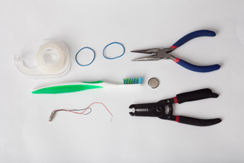
Here's what you'll need to build your own Bristle Bot!
    - 1 pager motor with two wires (1-volt to 3-volt motor) No pager motor? Buy one at an electronics store or remove one from a broken electronic device that buzzes or vibrates (e.g., cell phone, electric toothbrush, pager, etc.).
    - 1 button cell battery (1 volt to 3 volt, to match the pager motor)
    - 1 toothbrush with bristles set at an angle. No toothbrush with angled bristles? Put a book on top of a head with straight bristles. After a few minutes, the bristles will stay angled back.
    - Attachment materials (e.g., rubber band, twist-tie, zip-tie, tape, or double-stick foam tape)
    - Pliers/wire cutter
    - Wire stripper (optional)

2. 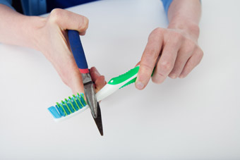
Cut off the toothbrush head
    - Snip off the head, using pliers or wire cutters.
    - Cut the handle close to the bristles.
3.
Test the battery and motor
    - Strip the end of the pager motor’s wires so about half an inch of the metal wire shows.
    - Touch one wire to the top of the battery and the other wire to the bottom.
    - The motor should spin vigorously.
4.
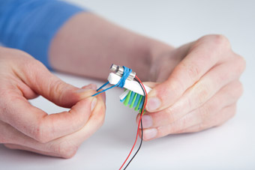
Attach the motor
    - Fasten the motor firmly to the top of the toothbrush head.
    - Use a rubber band, twist-tie, zip-tie, or piece of tape or double-stick foam tape.
    - Make sure the weight can spin without hitting the toothbrush.

5.
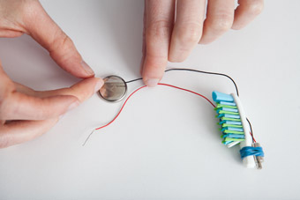
Connect one wire
Tape one of the motor’s wires to one side of the battery.
6. 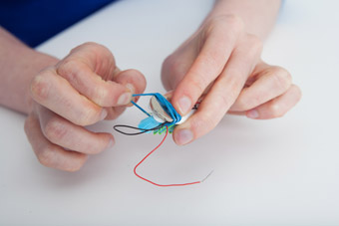
Attach the battery
    - Fasten the battery firmly to the top of the toothbrush, so the wire is on the bottom.
    - Use a rubber band, twist-tie, zip-tie, or piece of tape or double-stick foam tape.

7.
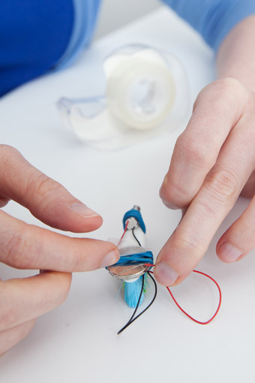
Connect the second wire
    - Connect the second wire so it stays in contact with the top side of the battery.
    - Not moving? Make sure the bristles are angled. The Bot moves in the direction that the bristles lean.
    - Spinning or not going straight? Shift the weight. The position of the motor and battery affects how the bristles touch the surface. Move the battery and motor to put weight evenly on all the bristles.
8.
Did you know?
A Bristle Bot is a lot like a Pogo Stick. For example, you bounce up and down on a Pogo Stick. The pager motor does the same thing with the toothbrush head—it bounces it up and down. To move forward on a Pogo Stick, you tilt it forward while bouncing. Similarly the Bot’s bristles all tilt. Because the pager motor bounces the Bot up and down on the tilted bristles, the Bot scoots forward.

9.
Try this next!
    - Bot bowling. Set up a bunch of small objects for your Bot to knock over. Let your Bot loose. How many did it hit?
    - Super-size it. Make a giant Bristle Bot out of a big brush (e.g., a scrub brush, shoe-polish brush, or hairbrush). Attach an electric toothbrush to the brush. Or attach a 3-volt hobby motor (from an electronics store). To make the motor vibrate, add a strip of duct tape to the metal shaft sticking out of the motor. Or tape a small bead to the shaft. When the shaft spins, the off-center weight of the tape or bead will bounce the motor (and the brush), moving it forward.

    - Credits:
http://pbskids.org/designsquad/build/bristle-bots/

