The GRADED ONE!!!!!!!
1. (AD ASSESSMENT) Look at Table 2, “Information on Selected Liquids,” on the next page (in student book). Use TEXXXI as you include the following points below. Be sure to complete a TEXXXI paragraph for each unknown liquids. Do not write in first or second person.
a. Compare the information from this activity with the information in the table. Look for similarities.
b. Based on their properties, what are the identities of liquid A and liquid B?
c. Support your answer with at least three pieces of evidence for each liquid.
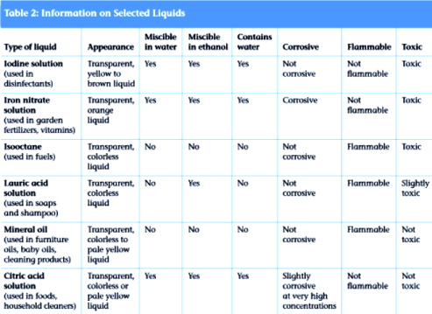

2. Based on the information in Table 2, “Information on Selected Liquids,” would you label liquid A or liquid B from the mixture as hazardous?

3. Using evidence from this activity, add the following to Student Sheet 5.1 for Liquid A and Liquid B
a. The name of the liquid you identified.
b. Under “Hazards,” write yes or no for those categories that apply.

Hazard | Liquid A: | Liquid B:
Corrosive

Flammable

Toxic

